Path for the Setup Project
\\nicsrv10\DevSuply\MPDSYS\POG Optimization Program\6 - POG Generation\P7-Implementation\Image Conversion\

Configuration Variables and their purpose:

The App.config File with different keys and its value is as shown below.
<appSettings>
<add key="imageProcessorPath" value="C:\Program Files\Target Corporation\ImageConverterSetup\"/>
<add key="imageProcessorExe" value="ImageConverter.exe"/>
<add key="ImageSourcePath" value="\\ttcfile07\Images\"/>
<add key="ImageDestinationPath" value="C:\DestImages\"/>
<add key="ConversionType" value="0"/>
<add key="DeptFieldNumber" value="001"/>
<add key="IsDeptFieldRequired" value="True"/>
<add key="defaultfileformat" value=".1"/>
<add key="newfileformat" value=".png"/>
<add key="interfileformat" value=".jpg"/>
<add key="numberofdays" value="500"/>
<add key="connectionstring" value="Data Source=sqlvirdev0010\dev10;Initial Catalog=prospace_tgt;Integrated Security=True"/>
<add key ="width" value ="200"/>
<add key="height" value="200"/>
<add key="Username" value="A033743"/>
<add key="Password" value="*****"/>
<add key="DayToRunImageConversion" value="Tuesday"/>
<add key="StartTime" value="13:40"/>
</appSettings>

Key | Default Value | Description
imageProcessorPath | C:\Program Files\Target Corporation\ImageConverterSetup\ | Path of the exe used for image conversion
imageProcessorExe | ImageConverter.exe | The exe name used for image conversion
ImageSourcePath | \\ttcfile07\Images\ | Images to be converted that is the source path
ImageDestinationPath | C:\DestImages\ | Images converted are placed in this folder that is the destination path
ConversionType | 0 | If 0- All Images will be converted  If 1- represents Scheduled process every week
DeptFieldNumber | 007 | deptfield number represent the images to be converted for that particular Department
IsDeptFieldRequired | True | this key represent if we need to filter using dept field number  True-Search For Particular Department  False-Search all the depatment in the source file path
defaultfileformat | .1 | The Default Image File Format
newfileformat | .png | The New File format of image after conversion
interfileformat | .jpg | Intermediate File Format
Width | 200 | Width of the image to be created
Height | 200 | Height of the image to be created
UserName | [dhc\UserId] | Account to be used to run service
Password | Password for above account | Password for the user account mentioned above
connectionstring | Data Source=sqlvirdev0010\dev10;Initial Catalog=prospace_tgt;Integrated Security=True | To establish connection to the SQL server we need this key.
DayToRunImageConversion | Tuesday | Day when you like to run the service
StartTime | 13:40 | Time when you like to run the service
numberofdays | 500 | This value is required to get the from date. FromDate is obtained by subtracting the Number Of Days from Today’s date.  We will get the records which fall between the FromDate and ToDate from the database.

Common Configurations

- imageProcessorPath : Specifies the path where the exe sits.
<add key="imageProcessorPath" value="C:\Program Files\Target Corporation\ImageConverterSetup\"/>

- imageProcessorExe : is the name of the VC++ exe created.Its value will be ImageConverter.exe. Need not be changed.
<add key="imageProcessorExe" value="ImageConverter.exe"/>

- ImageSourcePath : The path where the .1 files are stored. Default value is \\ttcfile07\Images\
<add key="ImageSourcePath" value="\\ttcfile07\Images\"/>

- ImageDestinationPath : The path where the .png files are to be stored. Default value is C:\DestImages\. You can Specify your own Destination Folder.
<add key="ImageDestinationPath" value="C:\DestImages\"/>

- defaultfileformat, newfileformat, interfileformat : need not be changed.
<add key="defaultfileformat" value=".1"/>
<add key="newfileformat" value=".png"/>
<add key="interfileformat" value=".jpg"/>

- Width and Height : take only integer values.
<add key ="width" value ="200"/>
<add key="height" value="200"/>

- UserName and Password : should be any user having read permissions on ImageSourcePath and Read and Write permissions on ImageDestinationPath.
<add key="Username" value="A033743"/>
<add key="Password" value="*****"/>

- DayToRunImageConversion : Any day of the week (eg: Tuesday).
<add key="DayToRunImageConversion" value="Tuesday"/>

- StartTime : The time you like to run the service (eg: 11:40).
<add key="StartTime" value="13:40"/>

1. Converting All Images

In this case the images mentioned in the Source File Path will be converted to .png and stored in the Destination Folder Specified. Under this Scenario we can either convert all the images available in the Source File Path or images of a particular Department in Source File Path.
Changes for Converting all the images

- ConversionType – Set Conversion Type to 0.
<add key="ConversionType" value="0"/>
- IsDeptFieldRequired- Set the value to “False” if conversion has to be made for all the images in source path.
<add key="IsDeptFieldRequired" value="False"/>

Converting images for particular department

1. ConversionType : Set Conversion Type to 0.
<add key="ConversionType" value="0"/>
2. IsDeptFieldRequired- Set this value to “True” if you want to convert the images of
particular department only.
<add key="IsDeptFieldRequired" value="True"/>
- DeptFieldNumber – Takes a three digit integer value which represents the
Department Number(which is the first three digit of the subfolder).
<add key="DeptFieldNumber" value="001"/>

2. Batch Process

In this case Conversion is done for a batch of Images which have been modified within a given period of time. We have two cases in this either all images belonging to this period can be converted or only the images belonging to particular department can be converted.

Changes for Converting all the Scheduled Images.

1. ConversionType : Set Conversion Type to 1.
<add key="ConversionType" value="1"/>
2. IsDeptFieldRequired : Set the value to “False” if conversion has to be made for
all the images you retreive from the database ( which are nothing but the images
between Fromdate and Todate retreived from the database).
<add key="IsDeptFieldRequired" value="False"/>
3. NumberOfDays : Set any integer value which is used for getting the FromDate(eg:
500).
<add key="numberofdays" value="500"/>

Changes for Converting Scheduled Images Of Particular Department.

- ConversionType : Set Conversion Type to 1.
<add key="ConversionType" value="1"/>
- IsDeptFieldRequired : Set the value to “True” if conversion has to be made for all the images you retreive from the database ( which are nothing but the images between Fromdate and Todate retreived from the database).
<add key="IsDeptFieldRequired" value="True"/>
- NumberOfDays : Set any integer value which is used for getting the FromDate(eg: 500).
<add key="numberofdays" value="500"/>
- DeptFieldNumber – Takes a three digit integer value which represents the
Department Number.
<add key="DeptFieldNumber" value="007"/>

Installing The Service

- When you Click on the setup and click the install option, The below first screen
Appears.

Click On the “Next” button.

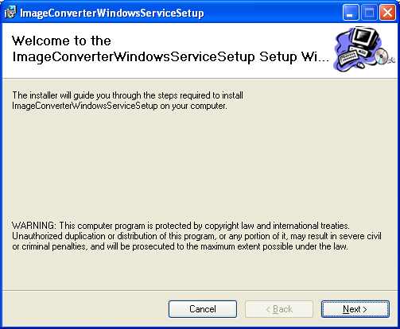

- Click On either the everyone or just me Option Button and then the “Next”.

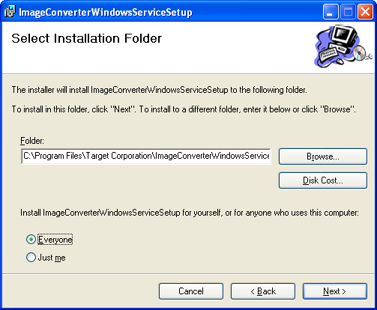

- Click “Next”.

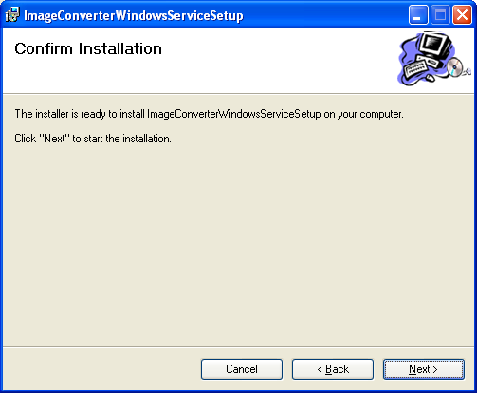

- The installation of Service is in Process and in the midst you will get the popup window as shown in the next screen.

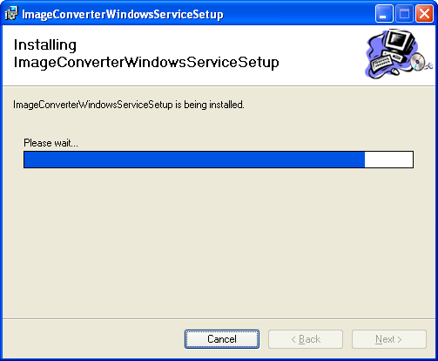

- Enter the user name as DHC\username and password, Click on Ok.

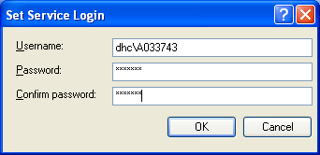

- Click Close to Exit.

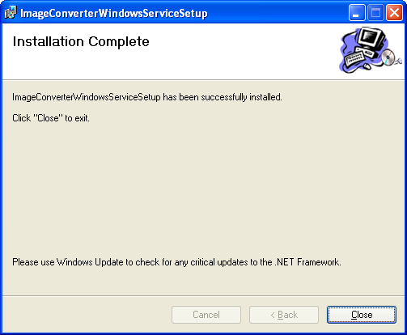

Starting And Stopping The Service

You can go to Services using the following:
- Go to Control Panel --> Administrative Tools --> Services
- Go to My Computer --> right Click on the icon --> Select Manage --> Services And Applications --> Services. You will get a screen as below.

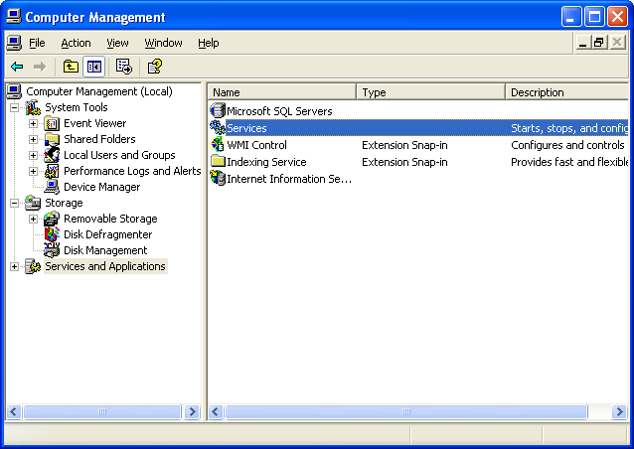

After Selecting the Services , you will get a Screen as shown below Select The setup you want to start(ImageConverterSetup], right click on it.
Click Start : To start the service.
Click Stop : To stop the service.

